Day 4 Javascript and JQuery Notes

Review Bootstrap homework (several share)

**JAVASCRIPT**

**TOPIC: Setup**

Create C:\TTS\Day 4 - Javascript and JQuery, open with VS

Create hellowWorld.js

console.log("hello world");

control F5

Create index.html

<!DOCTYPE html>

<html>

<head>

<title>Javacript</title>

</head>

<body>

<script src="helloWorld.js"></script>

<script>

console.log("hello world");

</script>

</body>

</html>

Open html in Live Server, F12, Click Console tab and blue circle

Change to Hello John and see the Chrome log update

Can also write to web page // put this in js file

document.write('hello John');

document.write('<h1 style="background-color:green">hello John</h1>'); // note “ is required here

Or can change element on webpage

<h1 id="header"></h1> put on HTML page

document.getElementById("header").innerHTML='Javascript is fun'; // put in js file

Or can type Javascript into Chrome console

document.write("hello");

Show first 6 slides

**Strings, Numbers, Booleans (show in Chrome console)**

“Java” +”Script”

“1234” vs. 1234

“12” + “50” vs 12+50

7+7+7 7+7+”7” “7”+7+7

-123.5

True

10=10

10==10

10===”10”

3===3.0

Typeof 3

Typeof 3.0

**Math and Datatypes**

10/3 10*3 10-3 10%3

9 + null // returns 9 - because null is converted to 0

"9" + null // returns "9null" - because null is converted to "null"

"5" + 2 // returns 52 - because 2 is converted to "2"

"5" - 2 // returns 3 - because "5" is converted to 5 Javascript written in 10 days

"5" * "2" // returns 10 - because "5" and "2" are converted to 5 and 2

Number(“9”)

String(123)

**Variables & Loose typing**

var x = 1;

var y = 2;

var z = x+y;

x=”Javascript” // loose typing

x=1 y=2 z=x===y // boolean

typeof z

const pet = “dog” // constant variable

pet=”cat”

**Math Object**

https://www.w3schools.com/js/js_math.asp

Circle area = Pi r2

Math.PI * (3*3)

Math.sqrt(9)

Math.round(4.8)

Math.random()

**Coercion and Prompt and Alert**

Coercion is essentially converting a type to another type

Implicit

console.log(7 + 7 + 7); // = 21

// First two 7's are calculated... then concatened into a string.

// returning a string value

console.log(7 + 7 + "7"); // = "147"

// The entire expression is implicitly converted into a string and concatenated

console.log("7" + 7 + 7); // = "777"

Explicit (show in js file. Will pop up in browser immediately)

var amountRaisedSoFar = 1000;

var newDonation = prompt("How much would you like to donate?");

amountRaisedSoFar = Number(newDonation) + amountRaisedSoFar; // Explicit coercion

alert("We have now raised: " + amountRaisedSoFar + "!");

**Null and undefined Show in Chrome console**

var something

undefined

typeof(something)

"undefined"

something = "asd"

"asd"

typeof(something)

"string"

var foo

undefined

foo=null;

null

typeof(foo)

"object"

Don’t use undeclared variables

**Flow Control**

var newDonation = prompt("How much would you like to donate?");

var donation = Number(newDonation) ;

if (donation > 100) {

alert("You are generous");

}

else {

alert("You are cheap");

}

**Challenge 1**

Write a JavaScript program that prompts for a circle radius and pops up “The circumference is *circumference of the circle*

var val = prompt("Circle Radius?");

var radius = Number(val) ;

var answer = 2*Math.PI*radius;

alert("The circumference is " + answer);

**Iteration for loop**

for (var i = 0; i <= 9; i++) {

console.log( i );

}

**Challenge 2**

Write js program to write to the console 99 bottles of beer on the wall down to 1,then write “Hey go buy more beer” and stop

var bottle = 99;

for (bottle; bottle >= 0; bottle --){

if (bottle === 0) {

console.log("Hey! Go buy more beer!");

} else {

console.log(bottle + " bottles of beer on the wall");

}

}

**While Loop**

var x = 0;

while(x < 10) {

x = x + 1;

// or x +=1

// or x++

console.log(x);

}

Add if(x===5) break;

**TOPIC: Switch Statement**

Copy from <https://www.w3schools.com/js/js_switch.asp> add console.log(day)

**TOPIC: Arrays**

<https://www.w3schools.com/js/js_arrays.asp>

Demo in Chrome console

var person = ["John", "Doe", 46];

person

person[0] = "Bill"

person

person.length;

person.sort();

**TOPIC: Functions (Can do these in <style> tag)**

function greeting() {

console.log("Hello Zack!");

}

greeting();

///////

var myName = "Zack";

function greeting() {

console.log("Hello " + myName);

}

greeting();

/////// pass a value

var myName = "Zack";

function greeting(name) {

console.log("Hello " + name);

}

greeting(myName);

/////// pass in multiple values

var myName = prompt("Name?");

var newLang = prompt("Language?");

var welcomeSaying = prompt("How do you greet others in that language?")

function greeting(name, language, saying) {

alert(saying + " " + name + ", nice to speak with someone who knows " + language);

}

greeting(myName, newLang, welcomeSaying);

/////// return a value (show in VS console)

function addItUp(x,y) {

return x + y;

}

console.log(addItUp(234,34));

**TOPIC: HTML Functions (show VS and Chrome side by side**

Type document in Chrome console

// describe the dom

// get the h1 items from the dom

var headers = document.getElementsByTagName("h1")

headers

// show the depth of info and methods on a h1

// Add this to html

<h2 class="subHeader">First sub header</h2>

<h2 class="subHeader">Second sub header</h2>

console.log(document.getElementsByClassName("subHeader"));

// dom manipulation

document.getElementById("header").innerHTML='Javascript is fun';

// add to html, show adding class

<style>

.myClass {

color:darkblue;

}

</style>

document.getElementById("header").className = "myClass";

**TOPIC: JQuery**

Create jquery.html

<!doctype html>

<html>

<head>

<title>Demo</title>

</head>

<body>

<a href="http://jquery.com/">jQuery</a>

<script src="https://ajax.googleapis.com/ajax/libs/jquery/3.5.1/jquery.min.js"></script>

<script>

</script>

</body>

</html>

Run and show [jquery.com](https://api.jquery.com/)

Click download



To do CDN look for [Google CDN](https://developers.google.com/speed/libraries/devguide#jquery)

Use 3.x snippet:

<script src="https://ajax.googleapis.com/ajax/libs/jquery/3.5.1/jquery.min.js"></script>

**Optionally download**

Do this one 

Save to C:\TTS\Day 4 - Javascript and JQuery should see it in VS

Change html to jquery-3.5.1.js

**TOPIC: JQUERY INTRO (Show in <style> tag)**

jQuery(document).ready(function () {

alert("welcome JQuery");

});

jQuery(document).ready(function () {

document.write("<h1>Hello Dude</h1>");

});

$(document).ready(function () {

$("a").click(function (event) {

alert("Thanks for visiting!");

});

});

$(document).ready(function () {

$("a").click(function (event) {

alert("As you can see, the link no longer took you to jquery.com");

event.preventDefault();

});

});

// Add this html

<h1>JQuery is OK</h1>

$(document).ready(function () {

$("a").click(function (event) { // change “a” to “h1” and test again

$('h1').html("some new text");

});

});

// Change css style

$(document).ready(function () {

$("h1").click(function (event) {

$(this).css('background-color', 'yellow');

});

});

// hover method

$(document).ready(function () {

$("h1").hover(function (event) {

$(this).css('background-color', 'yellow');

});

});

**TOPIC: JQUERY UI (Slide 57)**

// Add this to the header after jQuery link

<link rel="stylesheet" href="https://code.jquery.com/ui/1.11.4/themes/smoothness/jquery-ui.css">

// Put this just before my script

<script src="https://code.jquery.com/ui/1.11.4/jquery-ui.min.js"></script>

// Add html and draggable, resizable, datepicker

<body>

    <h1>JQuery is OK</h1>

    <a href="#">jQuery</a>

    <p id="resizable">Lorem ipsum dolor sit amet consectetur adipisicing elit. Autem corporis, quibusdam a corrupti et

        voluptate, ea recusandae aliquam culpa eaque atque in dolorum voluptatum eum unde officiis. Maxime, ratione

        maiores?</p>

    <p>Date: <input type="text" id="datepicker"></p>

    <script src="https://ajax.googleapis.com/ajax/libs/jquery/3.5.1/jquery.min.js"></script>

    <script src="https://code.jquery.com/ui/1.11.4/jquery-ui.min.js"></script>

    <script>

        $(function () {

            $('#draggable').draggable();

        })

        $(function () {

            $('#resizable').resizable();

        })

        $(function () {

            $("#datepicker").datepicker();

        });

    </script>

</body>

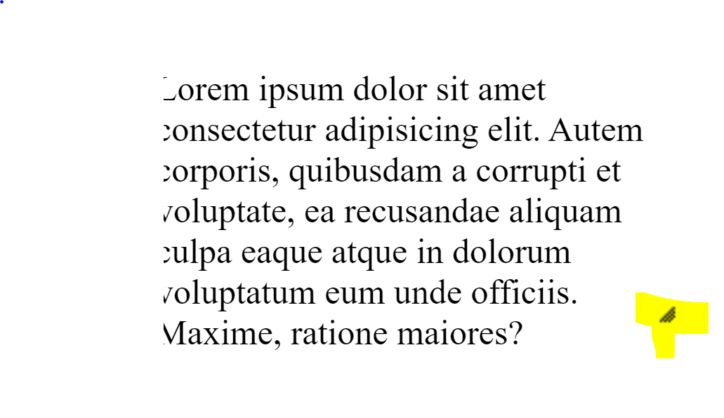

// Date Picker

<p>Date: <input type="text" id="datepicker"></p>

$( function() {

$( "#datepicker" ).datepicker();

} );

**Challenge 3 JQuery UI**

Goto <https://jqueryui.com/>

Pick out one or 2 Widgets to implement

**HOMEWORK:**

Show to students, watch videos, do tutorials, submit answer to challenges for js and JQuery